|  |
| --- |
|  |
| Capstone Project Document |

**WingS**

Report #6 – Installation Guide

|  |  |  |
| --- | --- | --- |
| **WingS** | | |
| **Group Members** | Đào Trọng Nghĩa | SE03220 |
| Lê Hồng Nhiên | SE03377 |
| Tạ Ngọc Duy | SE03267 |
| Đỗ Văn Tuấn | SE03297 |
| Hoàng Tuấn Anh | SE03108 |
| **Supervisor** | Mr. Nguyễn Văn Sang | |
| **Project code** | WS | |

**- Hanoi, 10/12/2016 -**

# SIGNATURE PAGE

AUTHOR: Đỗ Văn Tuấn 10/12/2016

Team member

REVIEWERS: Đào Trọng Nghĩa 09/12/2016

Project manager

APPROVAL: Nguyễn Văn Sang --/--/2016

Supervisor

Record of change

*A - Added M - Modified D – Deleted

|  |  |  |  |  |  |
| --- | --- | --- | --- | --- | --- |
| Effective Date | Changed Item | A,M,D | Change Description | Reason for Change | Rev. Number |
| 10/Dec/2016 | User installation | A | Add new |  | 1.0 |
|  |  |  |  |  |  |
|  |  |  |  |  |  |
|  |  |  |  |  |  |
|  |  |  |  |  |  |
|  |  |  |  |  |  |
|  |  |  |  |  |  |
|  |  |  |  |  |  |
|  |  |  |  |  |  |
|  |  |  |  |  |  |
|  |  |  |  |  |  |
|  |  |  |  |  |  |
|  |  |  |  |  |  |
|  |  |  |  |  |  |
|  |  |  |  |  |  |
|  |  |  |  |  |  |

Table Contents

SIGNATURE PAGE 1

1 INTRODUCTION 3

1.1 Purpose 3

1.2 Environment 3

2 Installation Guideline 3

2.1 Installing IIS on Windows 3

2.1.1 Creating Application Pool. 5

2.2 Add WingS web app into IIS. 6

# INTRODUCTION

## Purpose

This document contains guide-lines step by step to deploy WS Web App to local IIS Web Server.

## Environment

Following are the software required to start the WS system:

* Operating System: Windows 7, Windows 8, Window 10
* Browsers: Firefox 40, Chrome 44 or higher.
* Database: SQL 2008 or higher
* .NET Framework 4.5

# Installation Guideline

## Installing IIS on Windows

**Step 1:** Open Control Panel and click on “Programs” as shown in the figure below:

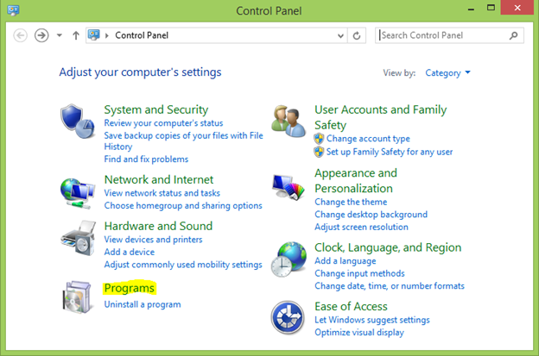

1. ****Windows Control Panel****

****Step 2:**** Then click on “Turn Windows features on or off” from the Programs and Features dialog and select “Internet Information Services” from the list as shown in the figure below:

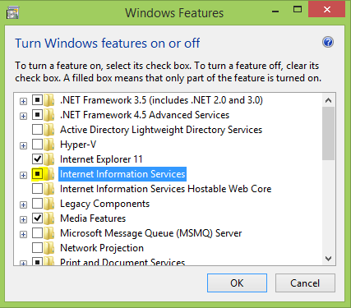

1. ****Windows Features dialog****

****Step 3:**** Expand IIS and check/enable all components under “World Wide Web Services” > “Application Development Features” as shown in the figure below:

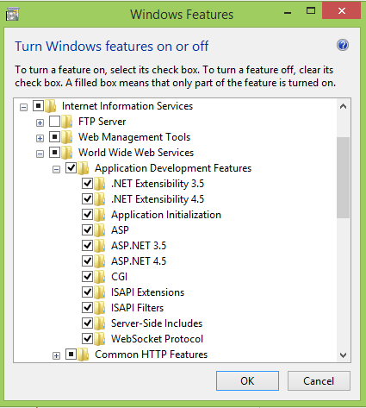

1. ****Windows Features dialog****

****Step 4:**** Click “OK” to let Windows install the required files. Once installed you may now close the dialog.

### Creating Application Pool.

Open the Internet Information Services (IIS) Manager and follow the procedure given below:  
**Step 1:** Select Application Pools -> add new 2 Application Pools is : ASP.NET v4.0 (select Integrated) and ASP.NET v4.0 Classic (select Classic) all .NET Framework select v4.0.30319.

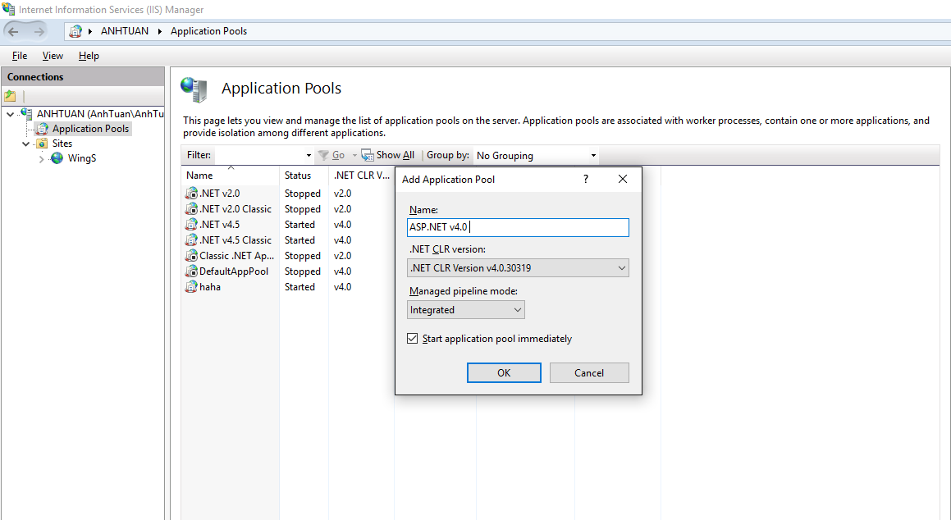

**Step 2:** Close IIS. After, go to Run enter:

%windir%\Microsoft.NET\Framework\v4.0.30319\aspnet _regiis.exe -i

Open IIS select ISAPI and CGI Restrictions as figure below:

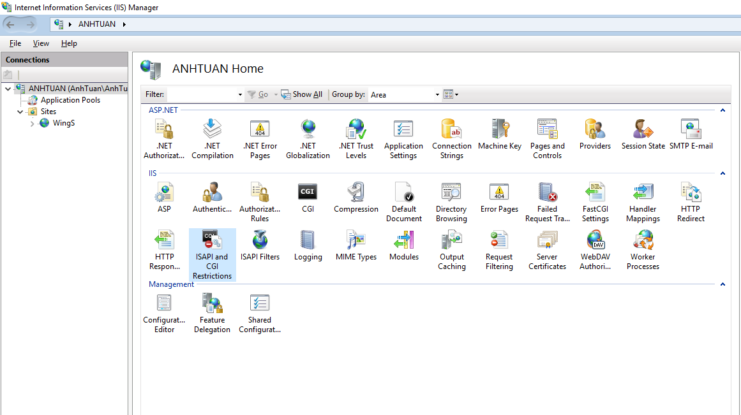

**Step 3:** Allowed 2 items ASP.NET v4.0.

**Step 4:** Select “Application Pools” and select “ASP.NET v4.0” from the list since our app uses this default application pool. If you are using a different application pool for your app then select that instead. On the left panel, select the link “Advance Settings” as shown in the figure below:

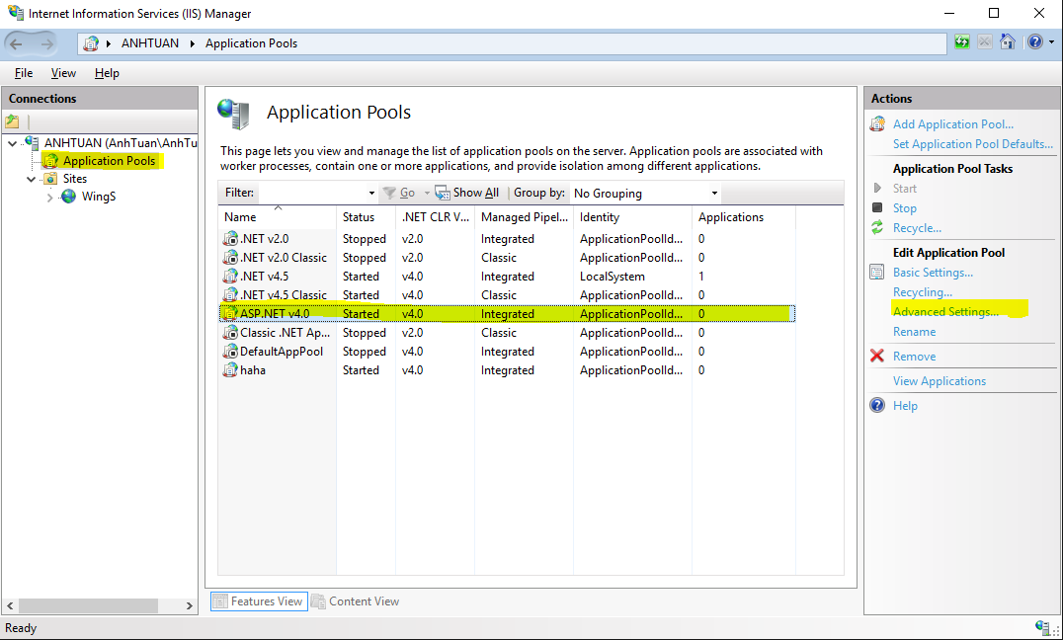

**Step 5:** Make sure that you select “Local System” as the Identity from the Advance Settings dialog as shown in the figure below:

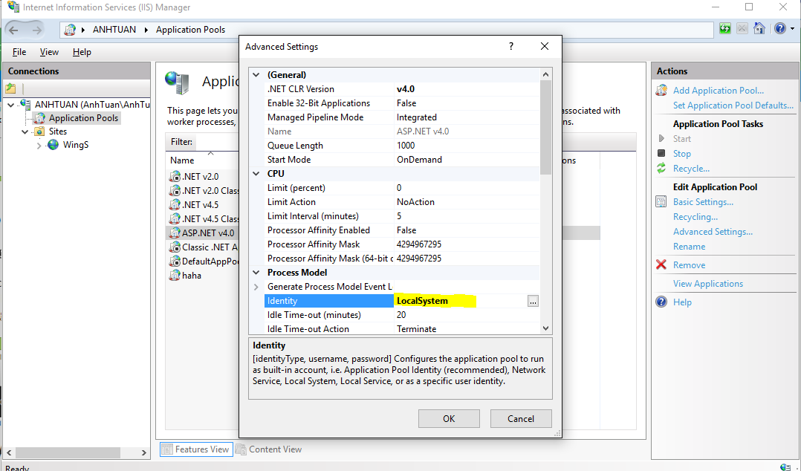

## Add WingS web app into IIS.

**Step 1:** Right click on “Sites -> select Add website…”

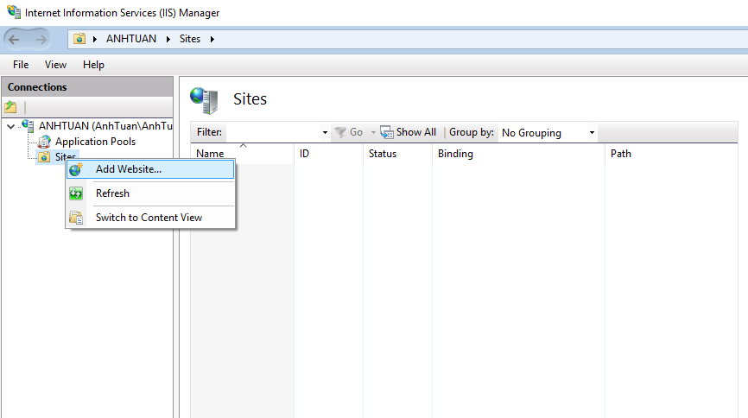

**Step 2:** Enter Site name and Select pool is ASP.NET v4.0.

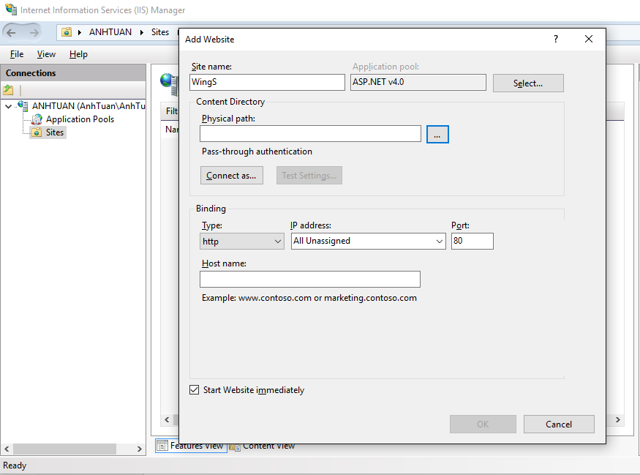

**Step 3:** Select Physical path (location store wings web app ) ,change default Port to 2710 and click “OK”.

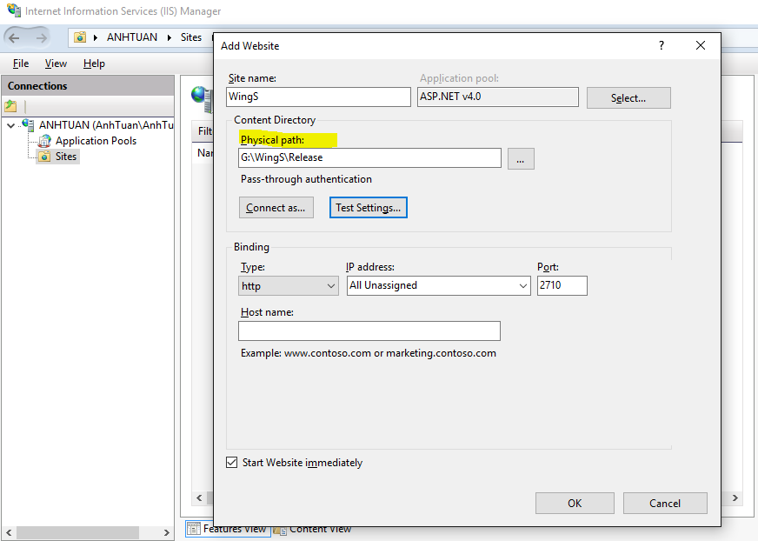

**Step 4:** Right click WingS (Site name is created), select “Manage Website -> Browse”.

